**Week 10**

1. What is your project about?

Deforestation + its causes and impacts

2. What is the data you plan to use?

* deforestation trend globally over the years:
  + <https://fra-data.fao.org/assessments/fra/2020/WO/home/overview>
  + <https://ourworldindata.org/deforestation>
* drivers/causes of deforestation + countries’ share of deforestation:
  + <https://ourworldindata.org/drivers-of-deforestation>
  + <https://www.worldwildlife.org/magazine/issues/summer-2018/articles/what-are-the-biggest-drivers-of-tropical-deforestation#:~:text=Beef%20production%20is%20the%20top,and%20fourth%20biggest%20drivers)%20combined>
  + <https://research.wri.org/gfr/forest-extent-indicators/deforestation-agriculture>
* Living Planet Index:
  + <https://www.statista.com/chart/17122/number-of-threatened-species-red-list/>
  + <https://www.livingplanetindex.org/latest_results>

3. What is the question you plan to answer?

What is deforestation and why should I care?

4. Why is this an important question?

*What is the current situation?*

* Deforestation is occurring at a rapid rate with increased development and we are not sure how long more the earth can hang on to its last resources left.
* Up to 15 billion trees are now being cut down every year across the world.
* Since 1990, the world has lost more than 420 million hectares or about a billion acres of forest, mainly in Africa and South America.
* About 17 percent of the Amazonian rainforest has been destroyed over the past 50 years.
* Destruction of the Amazon rose by 21 percent in 2020, a loss the size of Israel.

*Causes of deforestation?*

* Farming, grazing of livestock, mining, and drilling:
  + combined account for more than half of all deforestation.
* Forestry practices, wildfires and, in small part, urbanization:
  + account for the rest
  + In Malaysia and Indonesia, forests are cut down to make way for producing palm oil
  + In the Amazon, cattle ranching and farms—particularly soy plantations—are key culprits
* Logging operations:
  + Loggers, some of them acting illegally, also build roads to access more and more remote forests—which leads to further deforestation
* Development:
  + Residential
  + Offices etc
* Not all deforestation is intentional:
  + Some is caused natural factors like wildfires and overgrazing, which may prevent the growth of young trees.

*Why should I care about deforestation?*

* Forests are vital for the health of our planet
* They provide food and shelter for biodiversity
  + More than half the world's land-based plants and animals, and three-quarters of all birds, live in and around forest
  + Eighty percent of Earth’s land animals and plants live in forests, and deforestation threatens species including the orangutan, [Sumatran tiger](https://news.nationalgeographic.com/2017/12/palm-oil-sumatran-tigers-extinction-big-cats-animals/), and many species of birds
  + Removing trees deprives the forest of portions of its canopy, which blocks the sun’s rays during the day and retains heat at night. That disruption leads to more extreme temperature swings that can be harmful to plants and animals.
* Forests have a big influence on rainfall patterns, water and soil quality and flood prevention
  + The South American rainforest, for example, influences regional and perhaps even global water cycles, and it's key to the water supply in Brazilian cities and neighbouring countries. The Amazon actually helps furnish water to some of the soy farmers and beef ranchers who are clearing the forest.
* People
  + Millions of people rely directly on forests as their home or for making a living
  + There are some 250 million people who live in forest and savannah areas and depend on them for subsistence and income—many of them among the world’s rural poor
* Climate change
  + Trees absorb and store carbon dioxide. If forests are cleared, or even disturbed, they release carbon dioxide and other greenhouse gases.  Forest loss and damage is the cause of around 10% of global warming
  + cutting trees both adds carbon dioxide to the air and removes the ability to absorb existing carbon dioxide.
* Health and diseases
  + With wild habitats destroyed and human life ever expanding, the line between animal and human areas blurs, opening the door to zoonotic diseases
  + In 2014, for example, the Ebola virus killed over 11,000 people in West Africa after fruit bats transmitted the disease to a toddler who was playing near trees where bats were roosting.

<https://www.nationalgeographic.com/environment/article/deforestation>

<https://www.wwf.org.uk/learn/effects-of/deforestation#:~:text=Trees%20absorb%20and%20store%20carbon,we%20don't%20stop%20deforestation>.

5. Which rows and columns of the dataset do you plan to use, to answer this question?

* living planet index(line):
  + <https://www.livingplanetindex.org/latest_results>
  + planning to use only the first two columns and every row (
  + the living planet index is a measure of the state of the world's biological diversity based on population trends of vertebrate species from terrestrial, freshwater and marine habitats (<https://www.livingplanetindex.org/> )
  + biodiversity loss is mainly caused by deforestation and climate change
  + latin america and the caribbean, where brazil is, has seen a decrease of 94% of biodiversity (<https://livingplanet.panda.org/en-US/> )
* causes of deforestation(bar):
  + <https://ourworldindata.org/drivers-of-deforestation>
  + 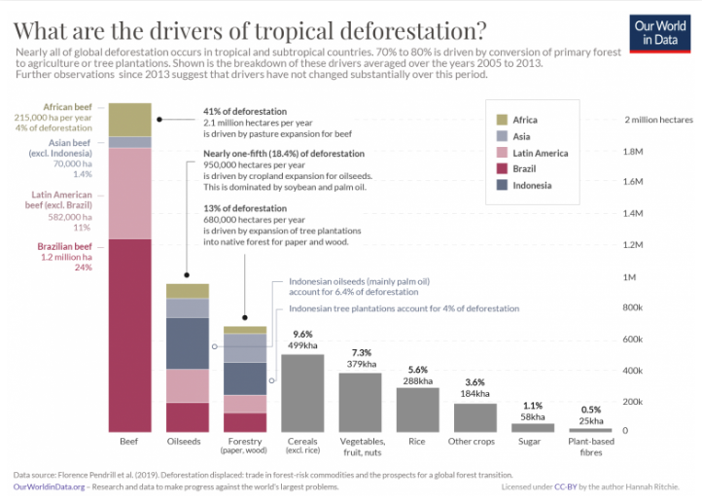
* countries’ share of deforestation(doughnut):
  + <https://ourworldindata.org/drivers-of-deforestation>
  + 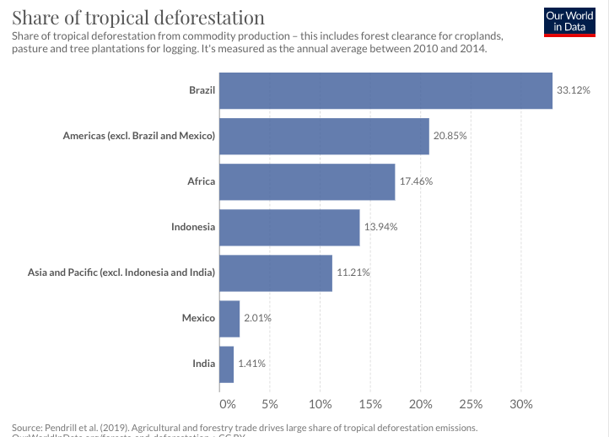

**Challenges and errors faced:**

| Challenges/errors | Line number | File name |
| --- | --- | --- |
| not sure how to make a stacked bar plot for just the first three of my bars in the “causes of deforestation” bar plot. e.g for beef bar, “african beef,brazilian beef etc” | 88-125  58 | main.js  index.html |
| cannot center the submit button for form | 132 | index.html |
| typewriter function is not working, also not sure how to make the typewriter effect continuous | 74-85 | main.js |
| not sure how to make the counter only increase once. currently, on every click, the number increases | 143-145  148-157 | index.html  main.js |
| when i add a new div at the start of th webpage, the other divs alignment are affected making it very troublesome to realign everything again: I think the main issue is that I am using  #soyKoala {  width: 800px;  height: 800px;  object-fit: contain;  position: absolute;  top: 380%;  left: 55%;  }  methods to arrange my elements and divs. Need to find a more efficient and sustainable way of aligning things!!! |  |  |
| For flexbox images, the images are not nicely centered above the text boxes below | 76-89  279-304 | index.html  css |

**Progress made:**

| Progress | Line number | File name |
| --- | --- | --- |
| Added 4 images for the impacts of deforestation to aid in visual attractiveness | 76-81 | index.html |
| added a title | 8 | index.html |
| Used flexbox for the first time to better align the explanations for the impacts of deforestation. | 76-89  279-304 | index.html  css |
| Added a pledge counter using concepts from Session 05 class challenges | 143-145  148-157 | index.html  main.js |
| Added Living Planet Index line graph (its at the end of the webpage, but I am planning to move it somewhere else later on). | 149  165-194 | index.html  main.js |
| Coloured the first two bars of the “causes of deforestation bar plot” a different colour from the other bars to draw attention | 58  88-146 | index.html  main.js |
| Added more images and information | 60 | index.html |

New ideas to add:

* Brazil is the world’s biggest deforester and yet the its forests have the highest tree species and biodiversity -> deforestation in brazil can lead to huge impacts on biodiversity if it is not halted
  + Rationale : this allows the audience to form links and instils greater impact
* Adding KoKo and the main character in the “story”
  + Rationale: greater engagement and more interesting
* Adding a pie chart poll to indicate their call to action

Things to do:

* find and add more data and visualisation
* **make everything more interactive (more onclick buttons for graph plots!!)**
* add a segment on what people can do to play their part
* **figure out how to do the “reduction in forested area” onchange bar!!!** <https://www.chartjs.org/docs/latest/developers/updates.html>